
NEW 2022 PREPARING FOR SUCCESS SYSTEM

What Would You Do And How Would Your Life
Change If You Had More Impact And Became More Successful (On Your Own Terms), A Better Leader, Built More Wealth,
And Radically Improved Your Cash Flow And Business Value -
All with Less Stress?

“If a blind man can gradually be helped to see it is not to be expected that he will at once discern new truths with an eagle eye. One must be glad if he sees anything at all, and if he begins to understand what he sees.”

“Your vision will become clear only when you can look into your own heart. Who looks outside, dreams; who looks inside, awakes.”

― C.G. Jung

Dave Frees’ Business Black Ops
Force Multiplier & Success
“Self Audit” & Success Preparation Process™
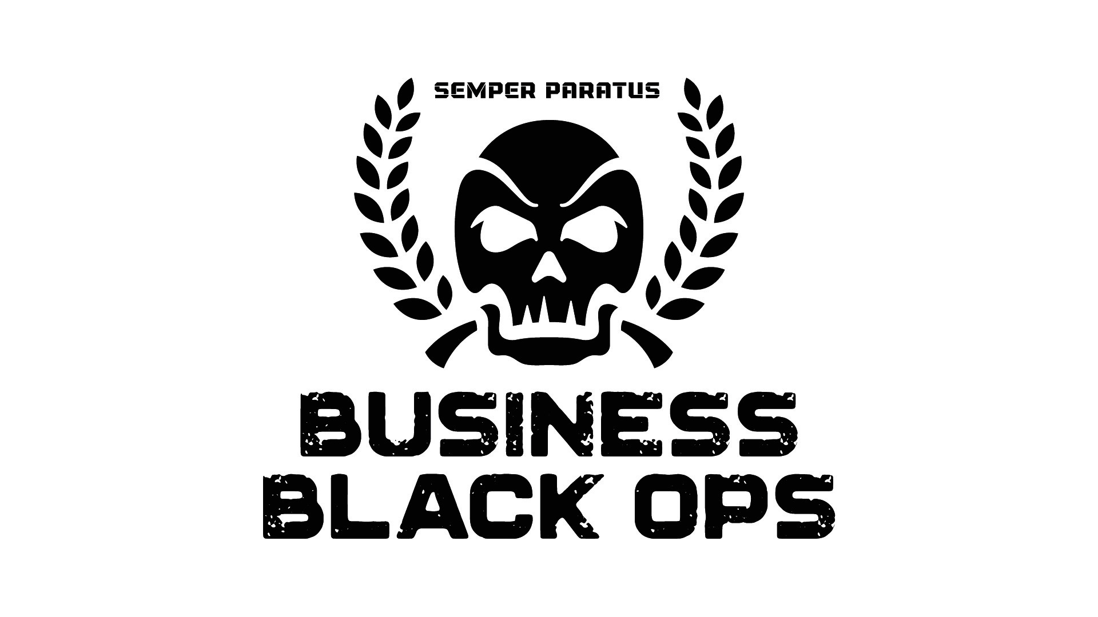

Enhanced Preparation For Massive Success, Wealth, & Optimized Results…

Completing and Returning This Annual Force Multiplier Self Audit Form is the Best Investment You Can Make in Your Business (or Practice), Your Personal Life, and for Even Greater Success on Your Own Terms.

It’s the Start to Truly Getting What You’ve Been Working For and That You’ve Already Earned & Deserve. And, Dave And His Team Use These To Make Sure You Get What You Need Most.

NOTE AND INSTRUCTIONS: If you’ve done this process before and have attended at least one BBO program, you might be tempted to skip the process or some questions. However, it’s often interesting, useful, and probably profitable to see how you’ve changed or how people have changed their perceptions of you (or the self-awareness you’ve developed).

No matter what your level, or prior experience, be sure to complete this process and upload it at membership.businessblackops.com.

Note: Questions you may have answered before are here to explore changes that you’ve made since your last event. New questions are designed to have a greater impact and to explore new ways of clarifying your own beliefs and values, as well as building profit, business value and more of the life you’re looking for. Do them all.

Part 1. Personal Self-Assessment and Current State Audit

Introduction and Background

This section is adapted from a now famous program that I gave to a group of women who created and owned businesses and professional practices but who were not yet achieving the wealth or the level of success that they wanted (and in some cases that they really needed) combined with the force multipliers that have at least doubled my business, and many others, over and over again.

In that program, I had the business and professional women go through an exercise to push the boundaries of their beliefs about what they could do and how they could do it in a way that would make life radically better. This activates the Meta Force Multiplier of Belief.

One attendee, who answered all these questions, told me years later that she “hated” the exercise and thought I was “just another motivational speaker.” But, she later admitted that within a year she had, to her amazement, achieved and exceeded all of her goals (both financial and emotional) and was happier in her practice than ever.

In this version, I have also meticulously included and embedded many other force multipliers that have helped me (as well as my coaching and consulting clients) to breakthrough barrier after barrier.

NOTE: The force multipliers you’ll learn are the strategic and tactical powerhouses that make a “success surge” possible, once your mind is open to it.

Why is this exercise so important and how does it work?

There is growing scientific evidence to support the idea, that everything you do successfully in business, and your life, flows from expanding your beliefs about what’s possible and learning how to systematically take a new belief from thought to action and reality. That process can be magnified even more by aligning with what you do best, with a clearly articulated purpose, values, and mission statement. The better you understand yourself, the greater the ease with which you function in the marketplace and the more likely you are to build a business or professional practice that is both consistent with your true strengths and desires and leaves the greatest legacy of your work.

When you have clarity and alignment, it’s easy to get new patients, customers and clients. However, getting the perfect ones that respect you and want to and can pay you…. that’s harder and takes some self-awareness, and specifically awareness of what makes you happy and how you can benefit others strategically.

If you’ve done this exercise or something like this before, do it again.

You’re a constantly changing organism with constantly changing beliefs, in a constantly changing work & personal environment. It’s probably different now. Make the new you work even better.

In addition to completing this assessment, remember to ask two or three people (who know you well) the following questions about you, then answer them yourself.

Note: Do not confine this to work-related matters.

Use your imagination. Remember to note your personal answers and the answers of two or three other people who know you well. It’s a good reality check.

So, this program involves becoming aware of, intellectually understanding, and then being able to implement and use force multipliers as drivers of radically better results with the use of the same or fewer resources of your own time, money and effort.

To help us and to help yourself, please take the time to complete the assessment. It will not be time wasted. It will help us to lead you directly to the part of your skill and ability and the part of your business that will produce 80 to 90 percent of the results with an expenditure of only 20 percent of the time money and resources. It will allow you, in a small fraction of the existing time that you’re committing to any particular activity, to get greater and greater results. Here’s to your success! Carry on.

1. I am happiest when… (name at least five times, circumstances, people)

Others Perceptions of When You’re Happiest:

Your Personal Responses:

2. I am most productive when…(name at least five times, circumstances, people)

Others Perceptions:

Your Personal Responses:

3. I am most creative/innovative when… (name at least 5 times, circumstances, people)

Others Perceptions:

Your Personal Responses:

4. I have achieved seemingly “magical” things most often/easily when…

Others Perceptions:

Your Personal Responses:

5. What sort of thing really excites you? What have they (your friends) heard you discuss most passionately?

Others’ responses:

Your Personal Responses:

6. Imagine that you have become famous (or more famous) in your lifetime, what possible things might you be celebrated for?

Others Perceptions:

Your Personal Responses:

7. What is the single most distinctive thing about you that defines, above all else, your individuality and uniqueness?

Others Perceptions:

Your Personal Responses:

8. What one thing are you best at, and better than anyone else that you know?

Others Perceptions:

Your Personal Responses:

9. Think laterally about a different arena or activity that you might be excellent at, preferably far removed from your current one. Be creative and surprising, perhaps not even entirely serious. If you were to start a new venture that becomes amazingly successful what might that new venture enterprise be?

Others Perceptions:

Your Personal Responses:

10. What is/are your real and current super power(s) and how did you develop it/them?

Others Perceptions:

Your Personal Responses:

11. What additional super power(s) would you like to cultivate/hone and why? What would then you do with it/them?

12. List every magazine, newspaper, podcast, publication/newsletter you’ve ever subscribed to for any substantial length of time (including those from other times in your life):

13. Same for newsletters & publications that you consistently enjoyed reading:

14. List every job or industry you’ve ever worked in – even if you’ve been out of it for a long time and the big lesson you learned there:

Job/Work:
Lesson:

Job/Work:
Lesson:

Job/Work:
Lesson:

Job/Work:
Lesson:

Job/Work:
Lesson:

Job/Work:
Lesson:

Job/Work:
Lesson:

Job/Work:
Lesson:

15. List every current and past “group” that you’ve been a member of. Examples could be – golf, Presbyterian church, girl scouts, cancer survivors support group, bowling league, pottery making class, Dave Frees’ Business Black Ops, Military Service.

16. List all current and past clubs, hobbies, fascinations and activities such as: horsemanship, stamp collecting, backgammon, owning rental property, investing, chess club, etc.:

17. List every major degree / training / educational experience/certification you’ve had (like travel to Africa, law medical and/or airplane mechanic school or nursing degree)/hypnosis or NLP certification from Dave Frees or anyone else:

18. List 5 topics you know a lot about, that most people don’t know you know a lot about (your dark secret interests):

19. List all topic(s) about which you own more than 5 books:

20. Describe a story of 2 major personal victories from at least two of the following: childhood; teen years; early adult; recent. Tell what happened and what made you feel GOOD about it or what you learned from each:

Part 2: Business

- What’s currently got you stuck (Indicate all that apply or list others)?

□ I have a million great ideas but I’m not sure what to do first, how to get started, or exactly how to do it.

□ I have strategic or tactical questions and need a place to go to get consistently good to great answers quickly and from people who have “done that.”

□ I have constant breakdowns of communications with customers and/or team/support members.

□ I want to radically improve the marketing skills of my team members.

□ I want to radically improve my own marketing skills.

□ I want to radically elevate my own leadership skills.

□ I want to level up my team’s leadership skills.

□ I am actively looking for (and would highly value) someone to hold me accountable and to regularly, and when necessary, give me a kick in the pants when I need it.

□ I’m looking for ways to grow my prospect list (with better quality prospects), to close higher value clients/customers/patients and or to increase my profit and/or value of my business/practice.

□ I am looking for guidance/coaching in how to maximize the value of my business/practice in preparation for an exit.

□ I want to have a bigger impact and to leave a legacy of my work.

□ Others: Explain them with specificity:

- Which of these would most likely help you to achieve your goals (and systems for achieving those goals) for this year and beyond?

□ Sales/Marketing or Leadership Training/Coaching for me or my team.

□ Develop the USP and client/patient/customer Avatars for each of my best products/services/and bundles.

□ Using the Business Whiteboard & Essential Business Function Programs to identify and activate additional profits, efficiencies, and effectiveness.

- Imagine that we meet one year from today. You say to me, “You and Business Black Ops made a huge positive difference in my business and in my life.” What will have happened to you and your business to create that feeling of amazing success, positive results, and radical improvement? What do you love most about the future transformation of your business or yourself?

- Are you more interested in □ launching a new business OR □ radically improving an existing business or practice?

- What single problem that, if solved, would produce the greatest breakthrough for your business, practice or life?

- Please list the business, spiritual or personal mentors who most inspire, influence and motivate you:

- How many Avatars have you developed?

- How many products, services or bundles of products or services do you sell/offer?

9. What are the demographics/characteristics of your best current client or customer Avatars (be detailed)?

10. What is the average lifetime value of 1) your average buyer, 2) your best current buyer [by product/service]?:

11. What is the average lifetime value of your next (and even better) future buyer/Avatar?

12. Where would you most easily find each of them physically and/or online? (Examples: a club they go to, a blog, podcast, magazine or publication that they read, associations, organizations that they belong to?)

Existing Avatar(s):

Existing Best Buyer Avatar(s):

Future Avatar(s):

13. How do you currently attract and close business? (List at least 2 - 5 ways)

Attract:

Close:

14. Do you currently have a client newsletter or follow up process? If so, describe it, how it is delivered, and offers/CTAs contained in it.

15. Do you have a process or processes for generating/triggering referrals from clients and/or centers of influence? If so, describe it/them.

16. Do you have a process/processes to encourage consumption of your product and/or services? If so, describe it/them.

17. What is/are your Unique Value Proposition(s) (UVP(s)) for your very best and most profitable products and/or services? The reason that this group should do business with you and only you – rather than your competition, and including the option of doing nothing.

Here’s a way to get started:

Complete this exercise BEFORE the event for your best and most profitable product/service:

I help:
(insert who you help – specifically)
________________________________________________________

________________________________________________________

To: ____________________________________________________
(insert a description of the problem you solve for them)
________________________________________________________

________________________________________________________

BY:
(insert what you do and how)
________________________________________________________

________________________________________________________

Even if: ________________________________________________
(insert common objections that your best buyers have in common)
________________________________________________________

________________________________________________________

Thanks for completing this process. It’s true. You have taken the first step to having a business that works for you and not one that enslaves you.

A business that creates wealth and happiness and the ability to do things for yourself and others and not one that produces constant stress, frustration, and a sense of being underpaid.

It’s time to make some truly effective changes and to be more of who you authentically are and want to be.

I’m looking forward to helping.

See you soon.
Dave Frees
dfrees@utbf.com
610-933-8069

If you’re not already following me personally on social media, take a minute to friend, LIKE, or follow me at these places to get loads of free information and invitations to our future events.
www.facebook.com/DavidFrees www.facebook.com/InTopForm

If you’re interested in:

1) Joining War Lord or Overlord Elite Private Coaching (closed enrollment after its limited membership is filled and totally closed by December 15th)

2) Becoming a consulting client for help with a specific project,

3) Attending any of the super secret new Business Black OPS Elite Special Forces Training programs for 2023, or

4) Having Dave do live or virtual leadership, communication skills, sales or marketing training.

Call Lisa and get a time when we can chat privately. She’s at 610-933-8069. And if you’re calling about the Business Black Ops program be sure to use a secure line (just kidding, there aren’t any thanks to the NSA) and be prepared to sign a non-disclosure agreement (I’m actually not kidding about this).

